Update application

Due to a product evolution, a one-time data migration is required.
This operation only needs to be performed once.
Afterwards, future updates will work normally without any additional steps.

Export the data from the old application
In the old application Accuracy2, go to the settings page. Find the application path folder as below and click on the blue link.

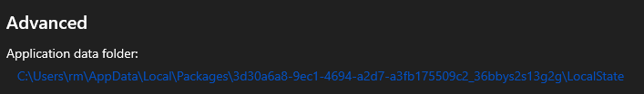

In the windows folder, export the oneof.dat, which is the database of your data (sequences, criterias, parameters…). You will need to import it in the new application.

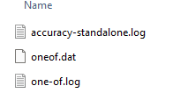

You can save the file where you want.

Import the data in the new application
When the oneof.dat is exported. You can now open the new application
ONEOF – Accuracy.
In the new application ONEOF – Accuracy, go to the settings page. Find the application path folder as below and click on the blue link.
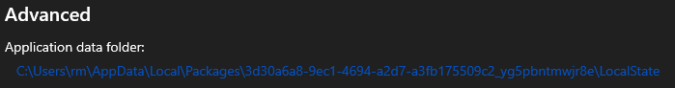

The link must be different from the old application link.

In the windows folder, replace the oneof.dat with the one you export from the old application.
Restart the application to apply changes and verify your data.

If you have any questions, feel free to contact the support at rodrigue.mullier@petitpierre.ch

